**Case Study: Guatemala**

**Problem**

The cooperative Todos Hermanos is considering using the mill it has for processing coffee for non-coop members. It’s been approached by a large entity that desires to process a large amount of coffee. Preliminary studies have shown that processing this coffee can cover the large loss the coop is incurring annually. The coop has asked you to analyze whether or not to accept this proposal.

**Overview of Coffee Growing in the Region**

The coffee produced in this particular region of Guatemala is very high quality, but individual farmers produce on a small scale, not enough to interact with the world’s leading coffee exporters. Traditionally, farmers have sold coffee mainly through intermediaries. These intermediaries own the trucks and drive door-to-door during harvest time and buy coffee cherries from the farmers. Historically, they offer very low prices for these raw cherries. About 30 years ago, non-profit projects brought wet mill technology into the region that allowed some farmers to process coffee cherries into parchment coffee. This change allowed farmers to capture much more value from the coffee and the prices offered by the intermediaries have gone up.

While the coffee growing process has grown more sophisticated in the region, the intermediaries have become more sophisticated as well. In order for farmers to improve their yields, they have begun using fertilizers, which allow them to increase coffee produced by as much as 50%. However, the fertilizer is extremely costly and smaller farm owners in this region, which make up most of the population, don’t have the resources to finance this fertilizer up front. Local rural banks have stepped in to offer financing, but require farmers to put up their land as collateral. Considering how volatile coffee prices are, and all the other risks that may make the farmer unable to deliver a harvest, farmers simply cannot take this risk. The same intermediaries that have offered to buy coffee from the farmers have diversified into offering fertilizer and financing as well. Usually, the arrangement is the intermediaries offer fertilizer or cash at the beginning of the harvest secured by the coffee harvest. One example arrangement is one pound of coffee for one pound of fertilizer. Arrangements like these are terrible for the farmers because coffee can be worth eight times more than fertilizer.

**People of Zacapa**

Zacapa lies on the Eastern side of Guatemala within a region known as the *Dry Corridor*. The people living in this region are extremely impoverished because of many factors working against them. First, they are limited by their location. Farmers in this region live high up in the mountains where transportation is extremely challenging as the roads are narrow, uneven and unpaved. It is very difficult for farmers to access not only markets for their produce, but also social services like schools and healthcare. Limited by the landscape, the farmers’ plots are also very small and strewn across the mountainside. On top of this, farmers in this region have large families. The land owned by the parents must go to more and more children and have resulted in small plots that are too small to support families. Finally, up until recently, the region has been very unstable. During the extended civil war, a lot of the atrocities were committed in this region. Even to this day, there is little government security in the region. Cartels or just wealthy individuals often dictate terms.

As a consequence, people in this region suffer one of the highest malnutrition rates in the world. Farming families often live hand to mouth and must rely on financing just to plant the crops for the following year. These families often live off of less than a dollar a day. When family members get sick, they frequently cannot afford medical access. Families also cannot afford to have children go to school beyond elementary school as schooling costs are expensive and the children are needed to work the land.

**General Overview of Todos Hermanos Cooperative**

Todos Hermanos Cooperative began operations in 2010 with a mission to provide access to coffee export markets for farmers near Zacapa, Guatemala. The Cooperative was founded by Bishop Rossolino Bianchetti Boffelli who believed that coffee can be an important tool to improve the quality of life for people in this region. The coop strives to allow local farmers to pool their resources and gain economies of scale so that they can export their main cash crop, coffee.

In order to promote farmer participation in the cooperative, Todos Hermanos provides advances so farmers can break away from the intermediaries who charge exorbitant interest rates. The coop’s initiative was to provide farmers with an alternative avenue for selling coffee. The farmers needed the advances to buy seed and fertilizer, and the coop’s mission was to provide such funding and charge a rate of interest that was only high enough to cover costs.

Given that the coop spent the majority of its initial funding on building a coffee processing facility, these advances must be financed. In 2010, the coop took out a bank loan so it would have funds to provide farmers with the means to plant coffee. Prior to the coop, the farmers took out advances from various intermediaries in the area, but these intermediaries charged high rates of interest, so much so that the majority of the farmers coffee crop belonged to the intermediaries before it was ever harvested.

In 2010 this system worked. Todos Hermanos provided advances to the farmers, they grew the coffee, the coop processed the coffee, and it was sold to Green Mountain for an amount sufficient to cover most the costs. Not all costs were recovered, but the coop was able to secure another loan thereby starting the process a second time. In 2011 they made the same advances, but when the harvest arrived coffee prices had fallen. A price above market was negotiated with Green Mountain, but the coffee was not sold in time to make the required payments to the bank and the loan had to be renegotiated. As of March 2012, the cooperative was in the process of delivering the coffee to Green Mountain, but the revenue received would not cover the costs the coop had incurred.

The Coop was in a position where it needed an alternative source of capital. Simply borrowing money and using that to make advance payments to farmers was not sufficient. The farmers would only sell to the coop if they were willing to make advances and pay market prices, and by doing so the coop was not able to recover its costs. The one asset that the coop had was a processing plant, which was unique to the region. Todos Hermanos had been approached by several different coffee intermediaries with inquiries about using the processing plant (“the dry mill”), but the coop was reluctant to agree, even though they needed the revenue to maintain the positive work they were doing.

If the coop could simply find a way to support its operations for several more years, and continue to provide increasing numbers of containers to Green Mountain, the company could become sustainable. If it could prove that it could deliver quality coffee to Green Mountain on a regular basis, and in sufficient quantity, then Green Mountain would offer financial support. The coop would not have to borrow from the bank to make the advances, but it could get such funding directly from Green Mountain. However, in order to make such a transition they had to survive for several more years, and coffee processing presented the most viable means for achieving such survival.

**Coffee Processing – From Cherry to Bean**

When coffee is picked from plants on farms throughout Guatemala it is in cherry form. Once the whole coffee cherry fruit is harvested it is ready for the first stage of wet mill processing. In traditional wet processing the coffee is first pulped in order to remove the outer fruit skin. Then it is floated in water to remove defective beans. The coffee is placed in a water bath and defective fruit will rise, while well-developed beans will sink to the bottom. The defective coffee can be skimmed from the top of the water and discarded if the bean is undeveloped, underdeveloped, or hollow.

Once defective beans are removed, the remaining beans are fermented to break down the fruit mucilage layer. Coffee is fermented for 12 to 24 hours so that mucilage can be washed off the coffee seed. During this phase, the coffee bean is not actually fermented, but the fruit coating is simply broken down through the action of peptic enzymes in the coffee. Finally, the beans are washed to remove the fruit that clings to the seed, and the coffee is dried.

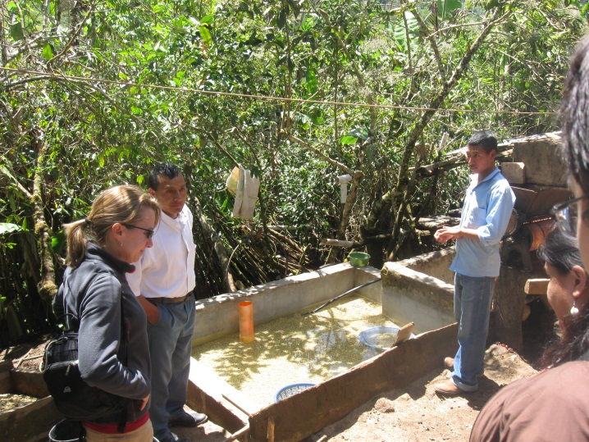 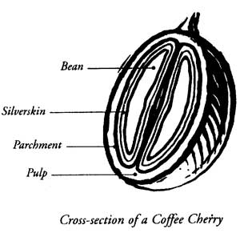

Once the skin and pulp is removed, the coffee is in parchment form and it is placed on outdoor patios where it is dried in the sun. Coffee is raked on the patio to ensure even drying. Parchment coffee is green coffee that is still in its outer shell, and this is the form it is in prior to dry milling. The outer shell will be removed by the dry milling process when the coffee is ready to be exported. Once the initial wet mill process is completed, the coffee needs to stay in its parchment form for between 30 and 60 days to stabilize. Coffee that is not allowed to rest for this period will lose its flavor.

Once the coffee has rested it can enter the dry mill process. Todos Hermanos Cooperative has machinery that mechanically hulls, grades, and sorts the parchment coffee. It is this machinery that the cooperative is considering using to process coffee that is not grown by cooperative members. The hulling process removes the entire parchment layer from wet processed coffee, and allows the beans to be sorted by size and weight. During the final phase of processing defective beans are identified and discarded by hand. Beans that are over fermented, have insect damage, or are deficient in color are removed to ensure that only the highest quality beans are exported.

The processing machinery owned and used by Todos Hermanos is an underutilized asset of the cooperative. The machinery was purchased in 2010 for approximately $700,000 by a generous donation from the Italian people acquired through Rossolino’s fundraising efforts. It is housed in a concrete block facility that sits beside the coops drying beds. Below are pictures of the building and machinery used by the coop:

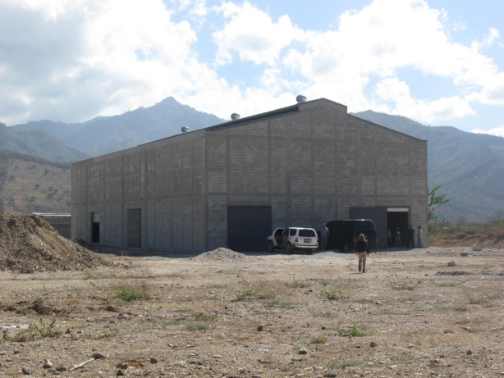 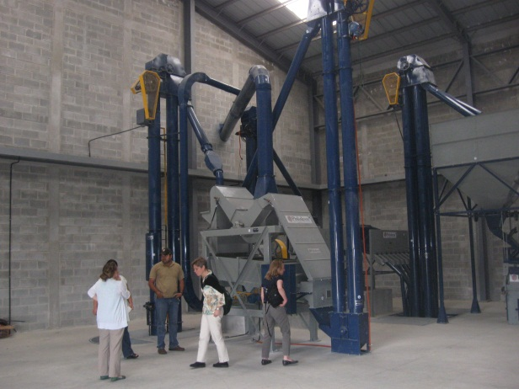

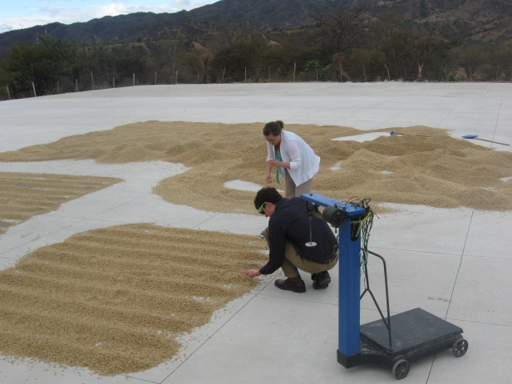 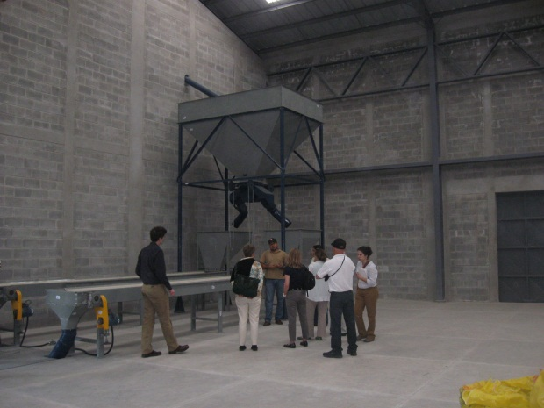

If the coop is to survive it must find a way to generate an additional 380,000 quetzals per year. The exchange rate in March 2012 was 7.8Q/$; thus this Q450,000 is the equivalent of almost $58,000. For each quintal of coffee the coop processes it could charge between Q110 and Q120, with costs of approximately Q80 per quintal. If we assume that they will charge Q120 and have sufficient demand at that price, they will make Q40/quintal. The dry mill machinery the coop possesses can process approximately 120 quintals of coffee per day; thus the coop could make Q4,800/day. In order to generate the amount of cash needed to sustain the business, this means the coop would have to run the mill for approximately 94 days. Since coffee is harvested at different times depending on altitude in about a three month window and since the parchment coffee can and must be stored for a while, it is possible to run the mill for half the year. While this would be a large undertaking for a newly formed coop, it is certainly within the realm of possibility. By engaging in the processing, the Coop could alleviate or altogether eliminate the cash flow issues it is currently encountering.

**The Real Issue**

When we first learned of the cash flow issues the Coop was experiencing, we understood they needed to find an alternative revenue source. The clear and obvious solution was to process coffee for neighboring producers. Problem solved, correct. Well, there was more to the issue than it seemed at first.

As stated above, intermediaries are the people in Guatemala who have coffee. The intermediaries in question were referred to as narco coffee dealers because the coffee they bought and sold was principally used as a mechanism to launder drug money. Thus, the issue for Todos Hermanos became whether it should enter into a business relationship with certain coffee processors that allegedly had ties to drug trafficking. If it could meet its expenses and continue its important work without such action then a relationship with the narco coffee dealers would not be entertained, but these were desperate times. Todos Hermanos needed the money, and without it all might be lost.

**Money Laundering**

The majority of criminal enterprises are centered on generating profits for the persons who carry out the illegal acts. Money laundering is the process the people use to clean their money, or, in other words, to disguise the illegal origin of their ill-gotten gains. The process is critically important to criminal enterprises because it allows the participants to enjoy the profits without jeopardizing the identity of the source. Drug traffickers use money laundering to shield their criminal endeavors. Traffickers who generate substantial profits must find a way to maintain control over the funds without drawing attention to the actual trafficking that is the source of the funds.

There are normally three phases to a money laundering operation. First, criminals introduce their illegal profits into the financial system by breaking large amounts of cash into smaller pieces and distributing them into various bank accounts and/or monetary instruments (commonly known as “smurfing”). Next, they layer the funds by moving the money around through wire transfers and investment instruments in an attempt to make the funds harder to track. Finally, the funds must be integrated back into the legitimate economy through investments in business ventures, real estate, or hard assets. This final stage is where individuals involved in drug trafficking in Guatemala use coffee distribution to “clean” their money.

By helping to facilitate or acquiescing to an economic system that includes money laundering, one could argue you are actually aiding in the proliferation of the underlying criminal activity. You are allowing criminals to make use of the funds they have obtained illegally. It could be said that you are actually condoning the illegal activity, in this case drug trafficking, by participating in a system known to be the source of laundering activities.

The foremost agency for combatting money laundering globally is the Financial Action Task Force on Money Laundering (FATF), founded in 1989 by the G7 countries. The FATF is a policy making body that works with legal, financial, and law enforcement experts to recommend legislation and regulatory reforms for member countries. Currently, there are 34 countries that participate, but Guatemala is not one of these countries.

**Criminal Influences in the Region**

Criminals use Coffee in Guatemala as a means to launder money. This is especially prevalent in the region around Zacapa where they buy cheap coffee from Honduras, mix it in with local coffee that they buy at a premium and sell to Guatemala City. However, this may not be the only source of criminal activity in the region. Because of the relative lack of government infrastructure and the fact that society in the region has been weakened tremendously by the civil war, there’s little here to combat lawless business practices, including narco money launderers.

The region is dominated by many “rich man on the hill” type models where a wealthy (often narco related) men hire people to be their intermediaries and give them a truck. Because of the much higher pay, people are drawn into the service of these men and are bound by the gift of the truck. They comprise of the middlemen in many areas who go door to door buying coffee and offering loans. However, because there’s no government oversight, and the dire need of the farmers, the terms of these loans are often outrageous. The criminal groups use the farmers as a means to disperse their illegal money and obtain clean money from coffee sales.

Todos Hermanos was aware of what was occurring around its plant in Zacapa. In fact, the facility next door to the coop was a known narco coffee establishment whose primary purpose was to clean the money that its owners had derived from illegal drug trafficking. The coffee intermediaries worked directly for the drug traffickers and their only interest in coffee was as a conduit for laundering money. Since the intermediaries are not particularly concerned with running a profitable coffee business, they are willing to pay high prices for the coffee they obtain, and this works to drive up the price that the coop has to pay to obtain the beans they need.

Pictures of the next door neighbor, a known narco coffee intermediary:

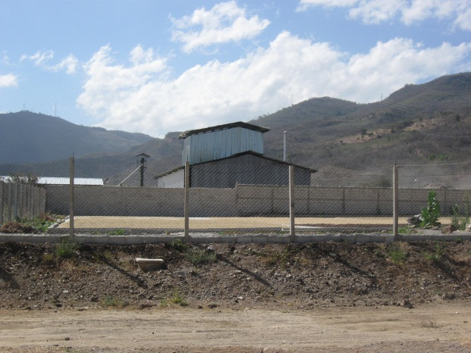 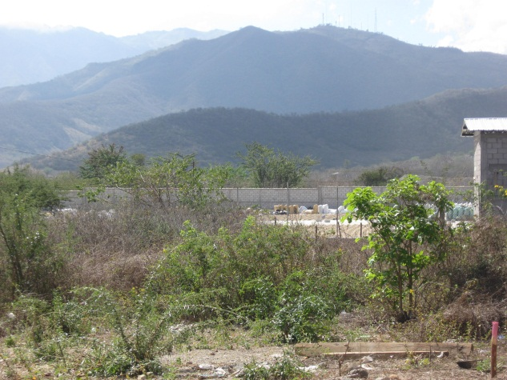

As a result the narco coffee dealers cause multiple problems for Todos Hermanos. They are responsible for many of the intermediaries who offer advances to the farmers in exchange for a majority of their coffee crop, essentially turning the farmers into indentured servants. They also purchase coffee in its cherry form for prices that are higher than other legitimate business offer. This causes the coop to pay higher prices than they otherwise would in order to get the coffee necessary to fill Green Mountain’s needs.

So the issue really is whether the Coop should process narco coffee, and by doing survive, thereby continue its good work with the poorest of the poor in Guatemala. Essentially, the Coop would be taking money from individuals who are known to be involved in money laundering so that it could survive and offer small farmers a way to get out from under the same intermediaries it was doing business with.

**Concerns Re: Work with Narco Coffee**

The following is a non-exhaustive list of concerns the Coop had if it engaged in a business relationship with the Narco coffee dealers:

1. What type of message would it send to the Coop farming members if they Coop began doing business with the same intermediaries that it was trying to get the farmers out from under?
2. By offering a service to narco coffee intermediaries wouldn’t the Coop actually be assisting the entities that are driving up the coffee prices the Coop is already having trouble paying?
3. Once you agree to a business relationship with a group of individuals you know are involved in illegal activity, how to you get out of that relationship if you want to terminate it?
4. Would the employees of the Coop be in any type of physical danger if they agreed to associate with narco coffee intermediaries?
5. How can you really tell if a particular intermediary is involved in the narco coffee trade? The next door neighbors clearly were involved, but what about other intermediaries?
6. Once you declare yourself open in the processing business, how do you tell some intermediaries that you will process their coffee and then say no to others, especially when the others are well armed and violent?
7. Are you actually supporting the drug trade by providing a service to entities that assist cartels in money laundering?
8. How would your donors react if they knew who you were doing business with, especially since the majority of the money to start the Coop came through Bishop Rossolino Bianchetti Boffelli’s contacts with the Italian Catholic Church?
9. How would your partnership with CRS be affected if it was known that you were engaging in business with individuals who were involved in money laundering?

**Alternatives to Narco Coffee Processing**

In order to guarantee the coop has enough working capital to continue operations, there are a few options available:

1. **Reduce Price**: The simplest method for covering the gap in profitability assuming the coop cannot sign on more farmers is to reduce the price the coop buys coffee from farmers. Last year, the farmers were paid Q14.6 per lb, or a little less than $2. If the coop wanted to cover all of its costs, it can only offer around Q8 per lb for coffee. The coop has voiced a few concerns about reducing the price paid to farmers because it will weaken the reputation and cohesion of the coop. This may cause farmers to drop out, not deliver on the promised amounts of coffee, or stop promising coffee to the coop and instead turn to the middlemen who charge them exorbitant amounts for the financing farmers need.
2. **Increase Volume**: Another alternative for the coop is to increase the amount of coffee they do export. Currently, the coop exports about 110,000 lbs of coffee a year, or roughly 2 containers. If the coop wants to recoup their costs at the existing price point, they must export 10 times as much or 20 containers. There is one concern here. In order to secure coffee from farmers, the coop needs to provide financing to the farmers. In order to increase the export quantity to 20 containers, the coop needs to raise 7x working capital, or at a minimum $396,000 US. Typically, when a coop grows to a large enough size, and obtains a good enough reputation, it has the leverage to ask the buyer to provide financing for the coffee. The coop needs to export about 5-6 containers before they have enough leverage.
3. **Process Only Small Farmers**: Each batch of coffee processed requires a lag time for the coffee to run through the system so as not to contaminate the next batch. For small batches such as 100 quintales, this may increase the price by as much as 15%. It is also more costly reaching out to multiple smaller farmers for orders, loading and logistics than a few However, only large organizations can generate this much supply. If the coop buys directly from larger local plantation owners who can generate over 100 quintales, it can be reasonably sure it’s not dealing with narco coffee.
4. **Stall for Time**: The coop has only started a year ago. The have only really exported one batch of coffee before. Perhaps going forward, the coop will be much more successful finding more farmers willing to commit coffee to the coop and building up a reputation. However, the coop is burning through capital annually at the rate of Q380,000 a year. At this rate, the coop will be unable to meet next year’s coffee financing cash requirements. If the coop can scale up production by one container a year, it will need to raise: Q2.25M, or $300,000 USD. However, this depends on how much coffee the coop can buy from the farmers and the coffee prices in those years.